SproutSong

AI & Student Prediction Safety Policy Document

Part J — AI-Assisted Analysis, Career Guidance & Student Prediction Governance

1. Purpose

This document defines how SproutSong / SproutMentors should safely use AI for students, teachers, parents, mentors, counsellors, and schools.

AI may be used for career guidance, academic performance analysis, counselling reports, learning recommendations, parent-ready summaries, and principal dashboard insights. Your existing Part J already identifies these as valid AI usage areas and requires data minimisation, removal of identifiers, prompt-log protection, human review, consent, explainability, and avoidance of harmful labels.

The goal is:

Use AI as an assistive educational support system, not as a final decision-making authority.

AI should help teachers, counselors, parents, and schools understand student needs better, but it should not label, rank, reject, shame, or permanently categorise a student.

---

2. Core AI Safety Principles

2.1 AI is assistive, not final

AI output must never be treated as a final academic, psychological, career, or behavioural decision.

Correct wording:

AI-assisted recommendation
AI-supported insight
Suggested area for review
Requires teacher/counsellor validation

Avoid:

Final decision
Confirmed diagnosis
Failure prediction
Student ranking
Permanent ability label

Your existing DPDP/security report also states that AI output should be treated only as a support tool and reviewed by authorised teachers or mentors before academic decisions.

---

2.2 Minimise student data sent to AI

Before sending data to an AI API, remove unnecessary identifiers.

Avoid sending:

Student full name
Parent phone/email
Admission number
Home address
Exact date of birth
Government IDs
Full documents unless absolutely required
Other students’ data
School-sensitive internal notes

Prefer sending:

{
"studentRef": "STU-ANON-1021",
"classLevel": "Grade 10",
"subjects": ["Maths", "Science", "English"],
"marksSummary": {
"Maths": 72,
"Science": 81,
"English": 76
},
"interests": ["technology", "design", "problem solving"],
"teacherObservation": "Needs support in time management"
}

Your AI governance guidance already requires not sending unnecessary identifiers, using anonymised student IDs where possible, and not storing full prompts with unnecessary personal data.

---

2.3 AI must use supportive language

The uploaded Part J screenshot and guide clearly says harmful labels must be avoided.

Avoid:

“This student is weak.”
“This student is not suitable for Science.”
“This child has poor intelligence.”
“High failure risk.”
“Low potential.”

Use instead:

“The student may need additional support in...”
“Current indicators suggest exploring...”
“Recommended areas for improvement...”
“The student shows stronger alignment with...”
“This recommendation should be reviewed by a counsellor/parent.”

This same “avoid / use instead” language is present in your Teamship Guide under Part J.

---

3. Where AI Can Be Used

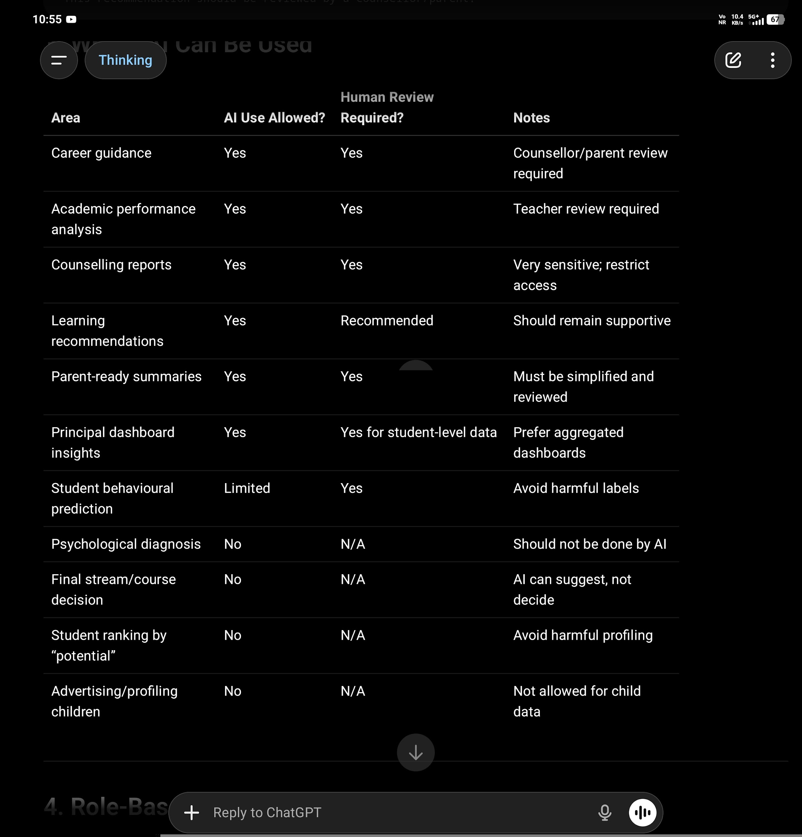

---

4. Role-Based AI Access Matrix

4.1 Student Access

Students should be allowed to access only their own AI-assisted outputs.

Students can see

Own learning recommendations
Own academic improvement suggestions
Own career exploration suggestions
Simple explanations of why a recommendation was made
Teacher/counsellor-approved AI summaries
Action plan / next steps
Positive strengths and improvement areas

Students should not see

Raw AI prompts
Raw model response before review
Risk scores
Hidden teacher notes
Parent financial data
Counsellor private notes
Other students’ data
Internal confidence scoring
Labels like “weak”, “low potential”, “high risk”
Unreviewed career recommendations

Recommended student-facing wording:

Based on your academic record, interests, and counselling inputs, the system suggests exploring the following areas. These are guidance suggestions only and should be discussed with your parent, teacher, or counsellor.

---

4.2 Parent Access

Parents should see reviewed, parent-ready summaries for their own child only.

Parents can see

Child’s AI-assisted academic summary
Career guidance summary
Recommended support areas
Suggested next steps
Counsellor-approved report
Explanation of data used
AI disclaimer
Human review status

Parents should not see

Other students’ comparison data
Raw AI prompt
Unreviewed AI response
Internal scoring model
Teacher-only internal notes
Sensitive counsellor notes unless approved
Private student reflections if confidentiality applies

Parent-facing wording:

This report includes AI-assisted educational insights generated from academic and counselling inputs. It has been reviewed for educational use. The recommendations are for guidance and should not be treated as a final academic or career decision.

---

4.3 Teacher Access

Teachers should access AI insights only for students/classes assigned to them.

Teachers can see

AI-assisted learning recommendations
Subject-level performance summary
Homework/assessment pattern insights
Suggested intervention areas
AI contribution percentage
Human review status
Data sources used
Confidence/explainability notes
AI output history for assigned students

Teachers should not see

Students from other classes/schools
Sensitive counselling notes unless assigned
Parent financial details
Raw identity documents
Teacher/counsellor private notes from other departments
AI prompts containing unnecessary PII

Teacher access must follow school-scope and object-level authorisation. Your access-control policy already requires role permission, school-level filtering, and object-level checks for students, parents, teachers, and school admins.

---

4.4 Counsellor / Mentor Access

Counsellors and mentors can access assigned student AI reports only.

Counsellors can see

Academic inputs
Interest profile
Career preference data
AI-assisted career suggestions
Parent/student consent status
Uploaded counselling documents
Prior reviewed AI outputs
Human review panel
Recommendation approval workflow

Counsellors should not see

Non-assigned students
Other school data
Unnecessary parent financial data after case closure
Raw prompts unless needed for review
System-level model configuration

Counselling data should be treated as highly sensitive. Your existing report recommends encrypting counselling notes and restricting counsellor access.

---

4.5 Principal / School Admin Access

School admins and principals should mainly see school-level and class-level insights.

They can see

Aggregated class trends
Aggregated subject performance
AI-assisted school improvement insights
Reviewed student reports where school policy allows
Teacher intervention dashboard
Consent status summary
AI usage summary

They should not see

Unreviewed raw AI outputs
Detailed counselling notes unless authorised
Sensitive student/private notes without purpose
Other schools’ AI data
AI provider raw prompt logs

---

4.6 Super Admin / Technical Admin Access

Super Admin should not automatically see all personal AI data.

Super Admin can see

System configuration
AI provider settings
Usage analytics
Processing logs
Error logs without PII
Consent status counts
Audit logs with masked data

Super Admin should not see by default

Raw student prompts
Full AI reports with PII
Counselling details
Parent contact details
Uploaded student documents

Access should require special permission and audit logging.

---

5. AI Assistance Percentage: 100%, 50%, 20%

You asked how a teacher can identify whether something is 100% AI, 50% AI, or 20% AI.

The safest approach is not to rely on AI text detectors as proof. Instead, track the document generation workflow inside your platform. The system should know how the content was created.

Use the term:

AI Assistance Level

Not:

AI Detection Score

Because “AI detection” from final text alone may be unreliable. The better technical method is platform provenance: who wrote it, whether AI generated a draft, whether a human edited it, and how much content was modified after AI generation.

---

5.1 AI Assistance Levels

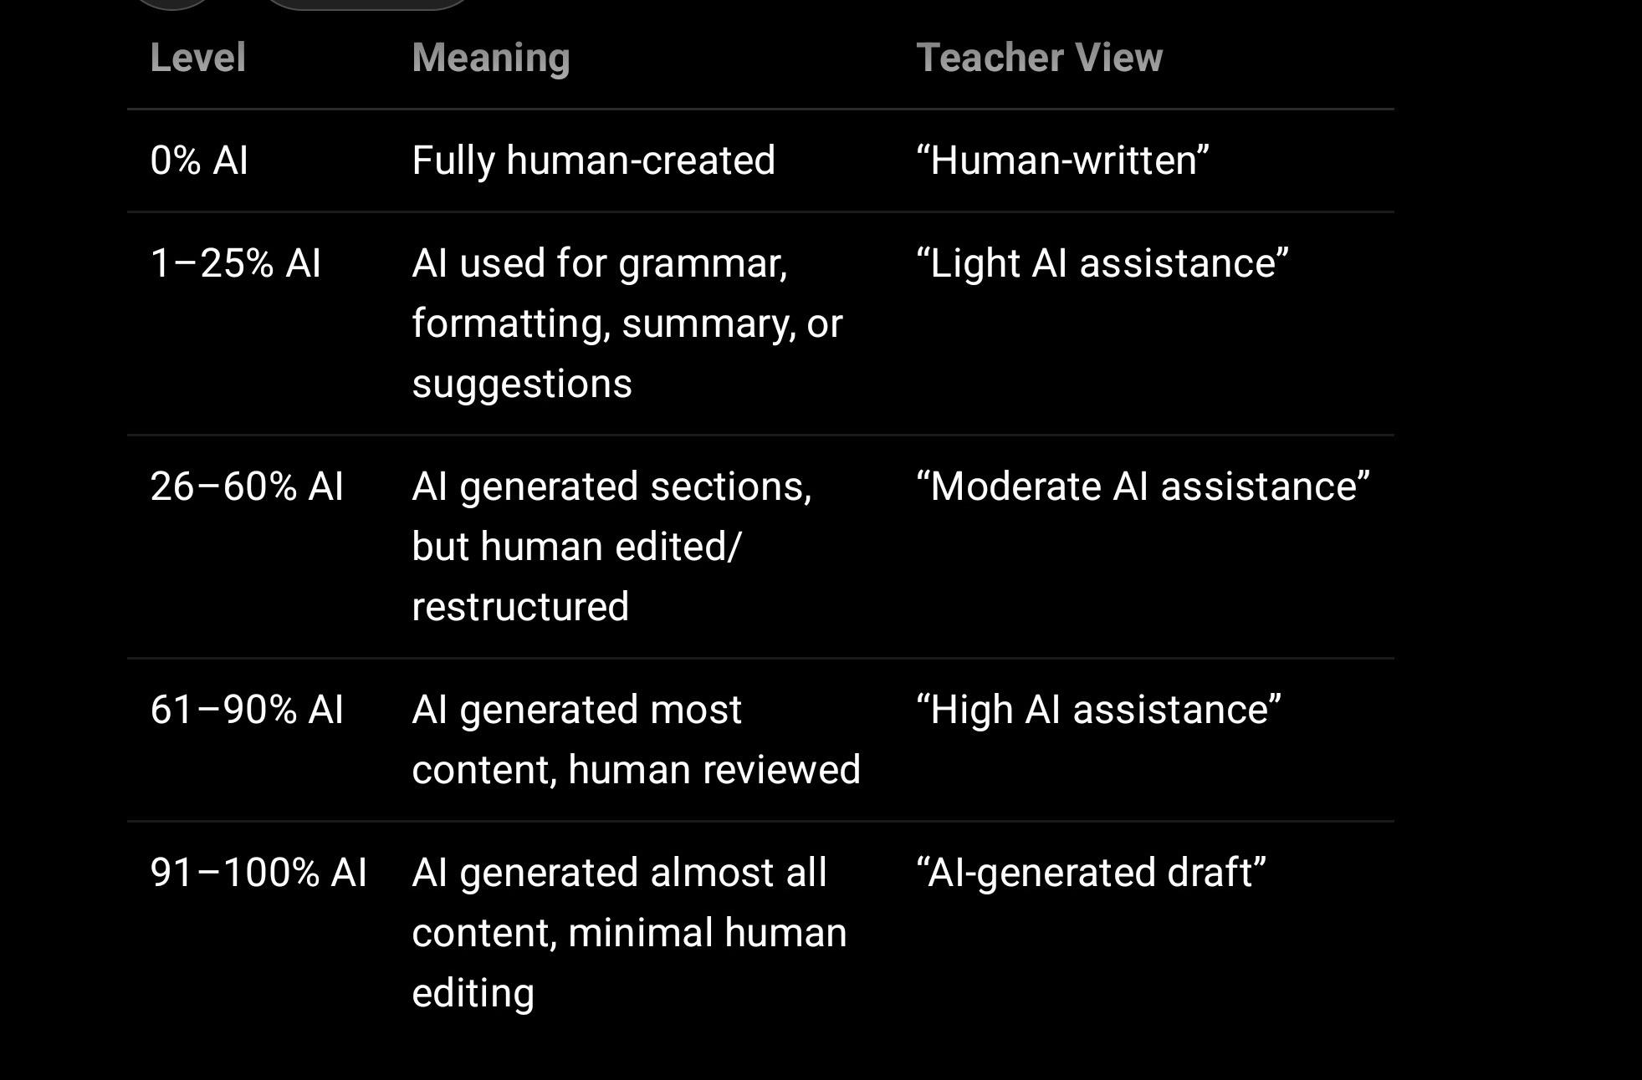

---

5.2 How to calculate AI Assistance Level

Track these fields:

aiUsage: {
used: Boolean,
source: "NONE" | "AI_DRAFT" | "AI_SUMMARY" | "AI_REWRITE" | "AI_RECOMMENDATION",
modelProvider: String,
modelName: String,

aiGeneratedCharacters: Number,
finalCharacters: Number,
humanEditedCharacters: Number,

aiAssistancePercent: Number,

generatedAt: Date,
generatedBy: ObjectId,

reviewed: Boolean,
reviewedBy: ObjectId,
reviewedAt: Date,

approvedForStudent: Boolean,
approvedForParent: Boolean
}

Approximate formula:

aiAssistancePercent =
Math.round((aiGeneratedCharacters / finalCharacters) * 100)

Better formula:

aiAssistancePercent =
Math.round(
((aiGeneratedCharacters - humanEditedCharacters) / finalCharacters) * 100
)

Example:

AI generated 1000 characters.
Teacher edited 600 characters.
Final report is 1200 characters.

AI assistance = ((1000 - 600) / 1200) * 100 = 33%

Show this to teacher as:

AI Assistance Level: Moderate — approx. 33%
Human Review: Completed
Reviewer: Class Teacher / Counsellor

---

5.3 UI Badge System

Use badges inside the teacher/counsellor panel:

Human-written
Light AI assistance
Moderate AI assistance
High AI assistance
AI-generated draft
Human reviewed
Parent-ready
Not reviewed
Needs counsellor review

Example:

Career Guidance Report
AI Assistance: 72% — High
Human Review: Pending
Status: Not visible to student/parent

After review:

Career Guidance Report
AI Assistance: 72% — High
Reviewed by: Counsellor
Status: Visible to parent

---

6. AI Output Visibility Workflow

AI output should not be visible to students/parents immediately.

Recommended workflow

Step 1: Teacher/Counsellor requests AI analysis
Step 2: System checks consent
Step 3: System minimises/anonymises student data
Step 4: AI generates draft output
Step 5: Output stored as "Draft - AI Generated"
Step 6: Teacher/Counsellor reviews and edits
Step 7: System calculates AI assistance level
Step 8: Reviewer approves for student/parent visibility
Step 9: Student/parent sees reviewed version only
Step 10: Full event is audit logged

Your internal report already recommends AI consent, anonymisation, AI usage logging, human review, correction of AI reports, and not using student data for AI training unless specifically consented.

---

7. AI Report Status Lifecycle

DRAFT_AI_GENERATED
UNDER_HUMAN_REVIEW
NEEDS_REVISION
APPROVED_BY_TEACHER
APPROVED_BY_COUNSELLOR
APPROVED_FOR_PARENT
APPROVED_FOR_STUDENT
REJECTED
ARCHIVED

Recommended schema:

const AiReportSchema = new mongoose.Schema({
schoolId: {
type: mongoose.Schema.Types.ObjectId,
index: true,
required: true
},

studentId: {
type: mongoose.Schema.Types.ObjectId,
index: true,
required: true
},

module: {
type: String,
enum: [
"CAREER_GUIDANCE",
"ACADEMIC_ANALYSIS",
"COUNSELLING_REPORT",
"LEARNING_RECOMMENDATION",
"PARENT_SUMMARY",
"PRINCIPAL_DASHBOARD"
],
required: true
},

purpose: {
type: String,
required: true
},

inputDataFields: [{
type: String
}],

anonymized: {
type: Boolean,
default: true
},

personalIdentifiersRemoved: {
type: Boolean,
default: true
},

provider: String,
model: String,

promptHash: String,

storeRawPrompt: {
type: Boolean,
default: false
},

aiDraft: {
type: String,
select: false
},

reviewedOutput: {
type: String
},

aiAssistancePercent: {
type: Number,
min: 0,
max: 100
},

status: {
type: String,
enum: [
"DRAFT_AI_GENERATED",
"UNDER_HUMAN_REVIEW",
"NEEDS_REVISION",
"APPROVED_BY_TEACHER",
"APPROVED_BY_COUNSELLOR",
"APPROVED_FOR_PARENT",
"APPROVED_FOR_STUDENT",
"REJECTED",
"ARCHIVED"
],
default: "DRAFT_AI_GENERATED"
},

humanReviewed: {
type: Boolean,
default: false
},

reviewedBy: {
type: mongoose.Schema.Types.ObjectId,
ref: "User"
},

reviewedAt: Date,

visibleToStudent: {
type: Boolean,
default: false
},

visibleToParent: {
type: Boolean,
default: false
},

consentRefId: {
type: mongoose.Schema.Types.ObjectId,
ref: "Consent",
required: true
},

createdBy: {
type: mongoose.Schema.Types.ObjectId,
ref: "User"
}
}, {
timestamps: true
});

AiReportSchema.index({ schoolId: 1, studentId: 1, module: 1 });
AiReportSchema.index({ schoolId: 1, status: 1 });

Your earlier schema recommendations already include an ai_processing_logs collection with schoolId, studentId, requestedBy, module, purpose, inputDataFields, anonymized, provider, model, outputRecordId, humanReviewed, reviewedBy, and createdAt.

---

8. AI Prompt Safety Rules

8.1 System prompt rule

Use a strict system prompt for all student-related AI requests:

You are an educational support assistant for a school platform.

You must:
- Use supportive and constructive language.
- Avoid harmful labels such as weak, low potential, poor intelligence, failure risk, unsuitable.
- Never make final academic, psychological, medical, or career decisions.
- Provide explainable recommendations based only on the given data.
- Use phrases such as "may need support", "current indicators suggest", "recommended areas for improvement".
- Always include: "This recommendation should be reviewed by a teacher, counsellor, parent, or school authority."
- Do not compare the student negatively with other students.
- Do not infer caste, religion, disability, mental health, family background, or financial status unless explicitly provided for a lawful purpose.

---

8.2 Prompt data minimisation

Bad prompt:

Student name is Riya Patel, DOB 12/03/2010, parent phone 9876543210, address..., marks...
Tell me if she is suitable for Science.

Good prompt:

A Grade 10 student has the following academic pattern and interests.
Maths: 72, Science: 81, English: 76.
Interests: technology, design, practical projects.
Teacher observation: needs time management support.
Generate supportive career exploration suggestions.
Avoid final decisions or negative labels.

---

9. Output Safety Filter

Before saving or showing AI output, run a safety check.

9.1 Blocked phrases

const blockedPhrases = [
"weak student",
"poor intelligence",
"low potential",
"high failure risk",
"not suitable for science",
"not suitable for commerce",
"will fail",
"bad student",
"poor mindset",
"dropout risk"
];

9.2 Safer replacements

const saferLanguageMap = {
"weak student": "student may need additional support",
"poor intelligence": "student may benefit from alternative learning support",
"low potential": "current indicators suggest areas for development",
"high failure risk": "may need timely academic support",
"not suitable for science": "may explore Science with additional guidance and support"
};

9.3 Code example

function validateAiOutput(output) {
const lower = output.toLowerCase();

const found = blockedPhrases.filter(phrase =>
lower.includes(phrase.toLowerCase())
);

if (found.length > 0) {
return {
safe: false,
blockedTerms: found,
message: "AI output contains harmful or unsupported labels."
};
}

return {
safe: true,
blockedTerms: []
};
}

If unsafe:

Status = NEEDS_REVISION
Do not show to student/parent
Notify reviewer

---

10. Explainability Requirement

Every AI output should answer:

What data was used?
What pattern was observed?
What recommendation was made?
Why was this recommendation made?
Who reviewed it?
What should the student/parent do next?

Student/parent-friendly explanation:

This recommendation was generated using your recent subject performance, interests, and counselling inputs. The system noticed stronger performance in Science and practical project-related interests. Based on this, it suggests exploring technology, applied science, and design-related pathways. This is not a final decision and should be discussed with your parent and counsellor.

Teacher-facing explanation:

Data used:
- Grade 10 subject marks
- Assessment trend
- Interest form
- Teacher observation

AI observation:
- Science and project-based interests show stronger alignment.
- Time management appears as an improvement area.

Recommendation:
- Explore applied science, technology, and design pathways.
- Provide study planning support.

Human review required:
Yes

Part J explicitly requires explainability: output should be understandable.

---

11. Consent for AI Prediction

AI consent must be separate.

Recommended consent text

I understand that SproutSong / SproutMentors may use AI-assisted or technology-assisted analysis to generate educational insights, career guidance, learning recommendations, counselling summaries, academic reports, and parent-ready summaries.

I consent to the use of the student's academic, counselling, attendance, interest, and learning-related data for AI-assisted educational support purposes only.

I understand that:
- AI output is assistive and not a final decision.
- AI-generated recommendations must be reviewed by a teacher, counsellor, parent, or authorised school representative before final use.
- SproutSong will minimise personal identifiers before processing where possible.
- Student data will not be used for advertising or harmful profiling.
- Student data will not be used to train third-party AI models unless separately and explicitly consented.

Checkbox:

☐ I consent to AI-assisted educational analysis and report generation.

Your guide identifies AI-based report generation as requiring specific consent, and children’s data requires verifiable parent/lawful guardian consent.

---

12. AI Processing Log

Every AI request must be logged.

const AiProcessingLogSchema = new mongoose.Schema({
requestId: String,

schoolId: {
type: mongoose.Schema.Types.ObjectId,
index: true
},

studentId: {
type: mongoose.Schema.Types.ObjectId,
index: true
},

requestedBy: {
type: mongoose.Schema.Types.ObjectId,
ref: "User"
},

requestedByRole: String,

module: String,
purpose: String,

inputDataFields: [String],

anonymized: Boolean,
personalIdentifiersRemoved: Boolean,

provider: String,
model: String,

promptHash: String,
rawPromptStored: {
type: Boolean,
default: false
},

outputRecordId: mongoose.Schema.Types.ObjectId,

aiAssistancePercent: Number,

humanReviewed: Boolean,
reviewedBy: mongoose.Schema.Types.ObjectId,
reviewedAt: Date,

visibleToStudent: Boolean,
visibleToParent: Boolean,

consentRefId: mongoose.Schema.Types.ObjectId,

ipAddress: String,
userAgent: String
}, {
timestamps: true
});

Do not log raw prompts containing student PII. Your logging guide says student names, parent names, addresses, counselling notes, passwords, tokens, and OTPs should not be logged; use ObjectId and redaction instead.

—

13. Teacher Review Screen Requirements

Teacher/counsellor should see:

Student: Masked or permitted identity
Module: Career Guidance / Academic Analysis
AI Assistance Level: 72%
Data Used: Marks, interests, assessment trend
Personal Identifiers Removed: Yes
Consent Available: Yes
AI Output Status: Draft
Blocked Language Check: Passed / Failed
Human Review Required: Yes
Approve for Parent: Button
Approve for Student: Button
Request Revision: Button
Edit Output: Button

Teacher should be able to:
Edit AI output
Reject unsafe output
Add human comments
Mark reviewed
Approve parent-visible version
Approve student-visible version
View AI assistance percentage
View what data fields were used
Flag harmful/inaccurate AI result

—

14. Parent View Requirements

Parent should see:
Reviewed AI-assisted summary
Strengths
Areas for support
Suggested next steps
Counsellor/teacher review status
Disclaimer
Data used summary
Contact counsellor / request correction option

Parent should not see:
Raw AI prompt
Internal AI score
Other students’ comparison
Unreviewed AI output
Sensitive internal teacher/counsellor notes

—

15. Student View Requirements

Student should see:

Positive strengths
Learning suggestions
Recommended areas for improvement
Career exploration options
Simple explanation
Encouraging next steps
Reviewed-by status

Student should not see:
Risk scores
Failure prediction
Negative ability labels
Unreviewed AI output
Detailed parent/counsellor notes
Hidden administrative comments

—

16. School / Principal Dashboard Requirements

Principal dashboard should prioritise aggregated insights.

Allowed:
Class-level performance trends
Subject-wise support needs
Number of students needing additional support
AI usage count
Reports pending human review
Consent pending count
Counselling cases requiring review

Avoid:
Ranking students by risk
Showing “weak students” list
Exposing counselling notes
Comparing children publicly
Showing unreviewed AI predictions

Use safe dashboard labels:
Students who may benefit from additional academic support
Students recommended for counselling follow-up
Subjects requiring reinforcement
Reports pending review

—

17. API-Level Protection

AI generation API should be protected.

router.post(
"/ai-reports/generate",
authenticate,
authorize("aiReports", "create"),
scopeToSchool,
validateAiReportRequest,
verifyAiConsent,
minimizeStudentData,
generateAiDraft,
runOutputSafetyCheck,
createAiReportDraft
);

AI approval API:

router.patch(
"/ai-reports/:id/approve",
authenticate,
authorize("aiReports", "approve"),
validateObjectId("id"),
scopeToSchool,
verifyReviewerAccess,
approveAiReport
);

Student/Parent fetch API:

router.get(
"/ai-reports/:id",
authenticate,
authorize("aiReports", "read"),
validateObjectId("id"),
scopeToSchool,
verifyAiReportVisibility,
getReviewedAiReport
);

Your access-control policy requires backend enforcement, school-scope filtering, role checks, and IDOR checks after resource fetch.

—

18. AI Report Visibility Logic

function canViewAiReport(user, report) {
if (String(user.schoolId) !== String(report.schoolId)) {
return false;
}

if (user.role === "student") {
return (
String(user.linkedProfileId) === String(report.studentId) &&
report.visibleToStudent === true &&
report.humanReviewed === true
);
}

if (user.role === "parent") {
return (
user.childIds.map(String).includes(String(report.studentId)) &&
report.visibleToParent === true &&
report.humanReviewed === true
);
}

if (user.role === "teacher") {
return user.assignedStudentIds
.map(String)
.includes(String(report.studentId));
}

if (user.role === "counsellor") {
return user.assignedCounsellingStudentIds
.map(String)
.includes(String(report.studentId));
}

if (["principal", "school_admin"].includes(user.role)) {
return true;
}

return false;
}

—

19. Data Retention for AI

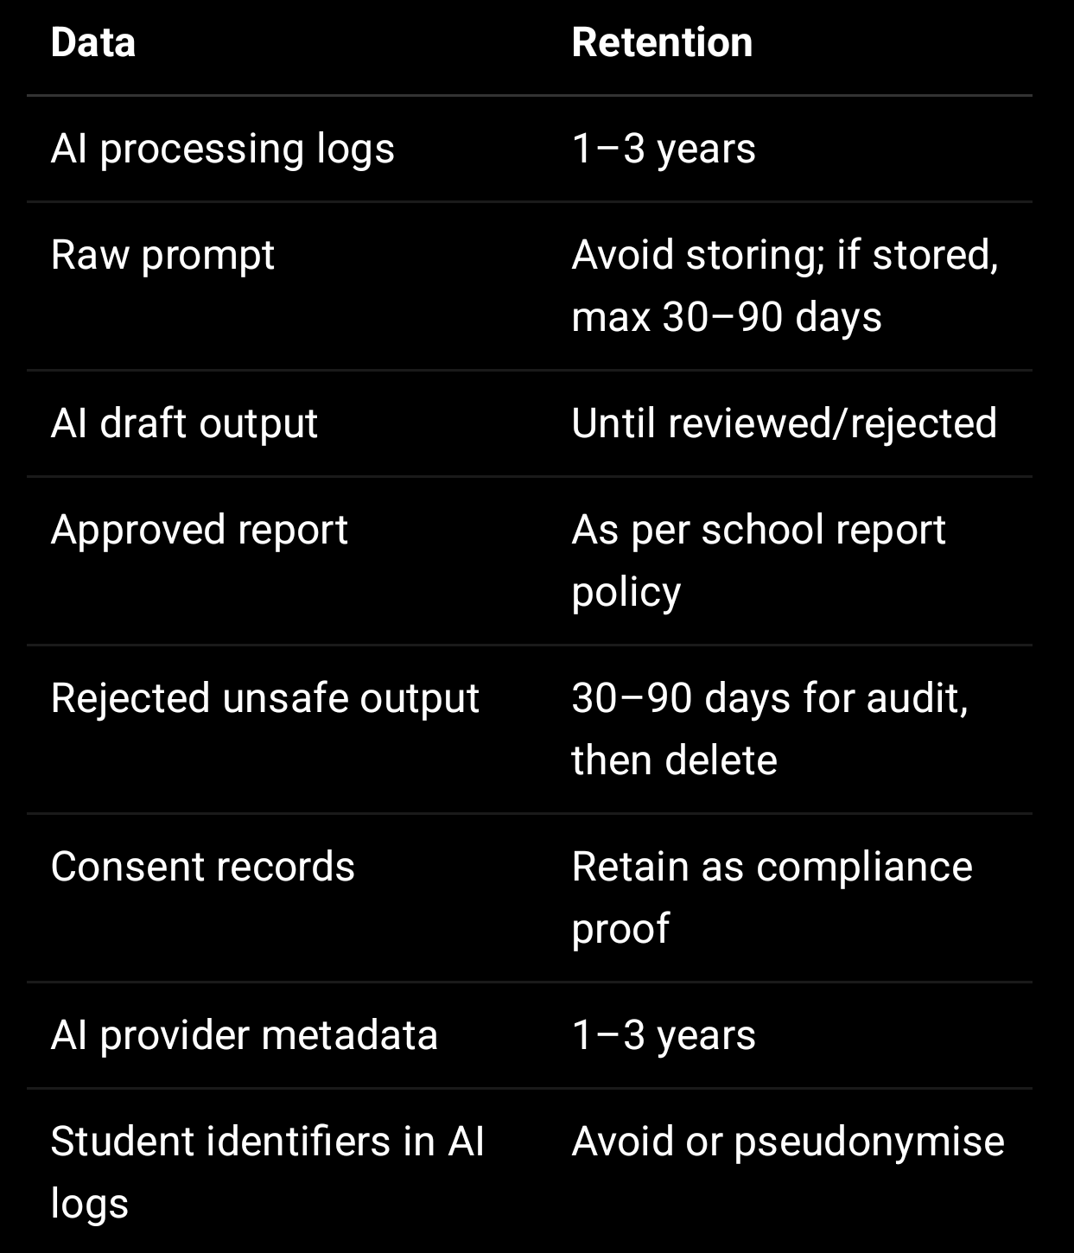

Your MongoDB security guide recommends safer alternatives for sensitive data, such as avoiding excessive student health data, raw session tokens, full documents, and storing encrypted counselling notes.

—

20. AI Safety Testing Checklist

Before launching any AI feature, test:

Does AI run only after consent?
Is parent consent verified for minors?
Are personal identifiers removed?
Is prompt logging disabled or hashed?
Is output reviewed before student/parent visibility?
Are harmful labels blocked?
Is AI assistance percentage shown?
Is report visible only to correct student/parent?
Can Teacher A access School B report? Must fail.
Can Parent A access another child’s AI report? Must fail.
Can student see unreviewed output? Must fail.
Is every AI generation audit logged?
Can user request correction of AI report?
Can admin see raw sensitive AI data without permission? Must fail.

—

21. Final AI Policy Statement

Use this in the AI Usage Policy page:

SproutSong / SproutMentors uses AI-assisted tools only to support educational guidance, academic analysis, counselling preparation, learning recommendations, parent-ready summaries, and school insights.

AI outputs are not final decisions. They must be reviewed by authorised teachers, counsellors, parents, or school authorities before use.

SproutSong avoids harmful profiling, negative labelling, and permanent categorisation of students. The platform uses supportive language and focuses on improvement, guidance, and student wellbeing.

Student data is minimised before AI processing wherever possible. Personal identifiers are removed where not required. AI processing is logged, consent-based, access-controlled, and subject to human review.

—

22. Implementation Priority

Start implementation in this order:

- Add separate AI consent.
- Create ai_reports and ai_processing_logs collections.
- Add AI data minimisation layer before API call.
- Add harmful-label output safety filter.
- Add human review workflow.
- Add AI assistance percentage tracking.
- Add role-based visibility for student/parent/teacher/school.
- Add correction request flow for AI reports.
- Add dashboard showing pending review, approved, rejected, and unsafe outputs.
- Add audit logs for generation, review, approval, visibility, and download.

